TOMATO VARIETIES

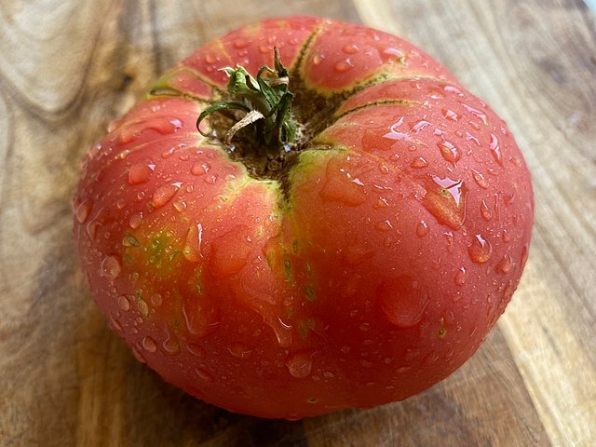
BRANDYWINE
Heirloom. 90-100 days. Large, deep scarlet-red, beefsteak fruits. Excellent flavor. Fruits can weigh up to 2 lbs. Excellent fresh from the vine or cooked for sauces, pasta dishes or casseroles. Indeterminate stake habit.

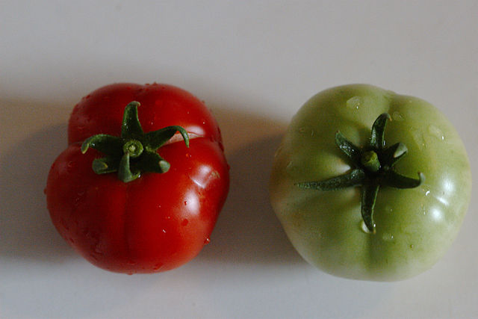
BUSH EARLY GIRL
(F-1 Hybrid). 63 days. High yielding sister of the traditional Early Girl; but with determinate bush habit. Bright red fruit, 6-8 oz. fruits. Good for areas with a short growing season. Perfect size for fresh salads or snacking. Disease resistant. Determinate bush habit.

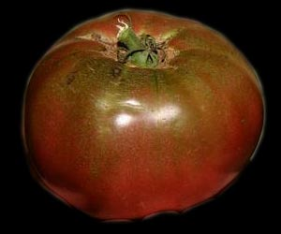
CHEROKEE PURPLE
Heirloom. 72 days. An unusual tomato with medium-large, flattened globe fruits that are dusky pink with darker pink/ purple shoulders. The multicolor interior is purplish/pinkish. Abundant, fruits are very sweet and juicy with a smoky flavor. Thick, rosy brown skin resists cracking. Good foliage cover prevents sunburn. Relatively short, indeterminate vines. Indeterminate stake habit.

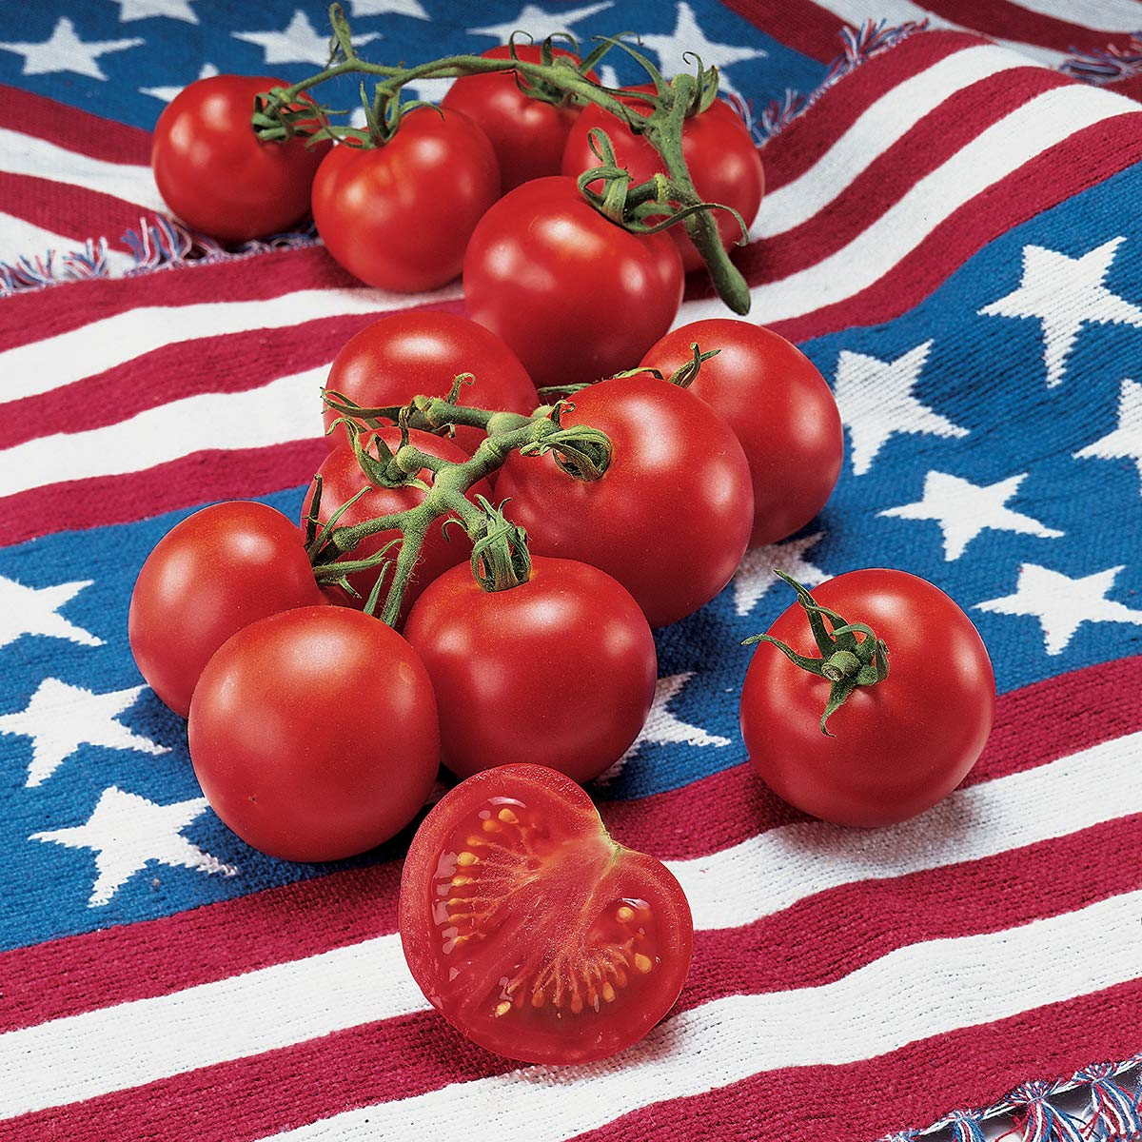
FOURTH OF JULY
(F-1 Hybrid). 49 days. The first to ripen by Independence Day. Produces 3-4 oz. medium small fruits all season long. Indeterminate stake habit.

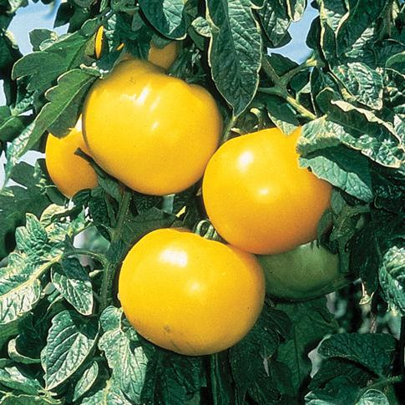
LEMON BOY
(F-1 Hybrid). 72 days. The first really true yellow variety, not golden. A heavy producer of 7-8 oz. fruits that are very tasty and mild. Beautiful bright fruit with mild flavor. Plants adapt well to variable conditions. Wonderful in fresh salads or vegetable trays. Indeterminate stake habit.

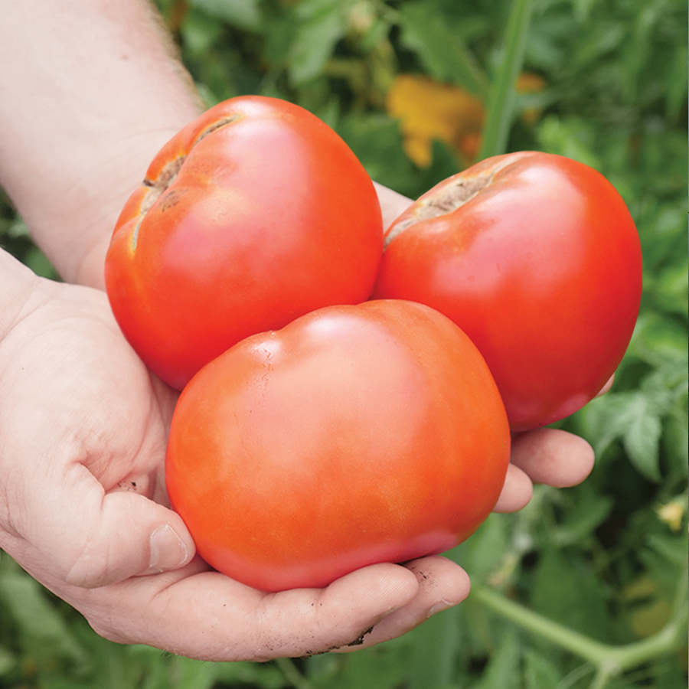
PARK’S WHOPPER
(F-1 Hybrid). 65 days. A home gardeners dream. Fruits are 4 in. or more and produces a good yield of beautiful big tasty red fruits. Ripens uniformly, even when the weather is overcast. Excellent for salads and sandwiches. Crack and disease resistant. Indeterminate stake habit.

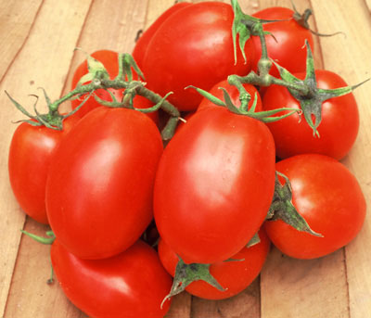
ROMA VF
Heirloom. 75 days. Plum shaped 2 oz. fruit, ideal for paste or puree. Fusarium and Verticillium resistant. Determinate bush habit.

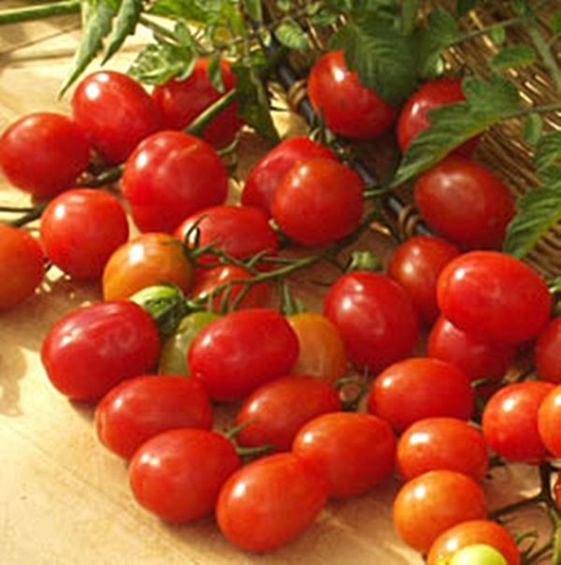
CUPID (GRAPE)
(F-1 Hybrid). 66 days. This is the ultimate in small fruited, grapeshaped tomatoes. Far superior, 1/2 oz. (20 grams) fruits have more natural sugars, with higher productivity. Fruits are 1-inch, firm but juicy and supremely sweet, with just enough tomato tang. Great in salads or for snacking. Disease resistant. Indeterminate stake habit.

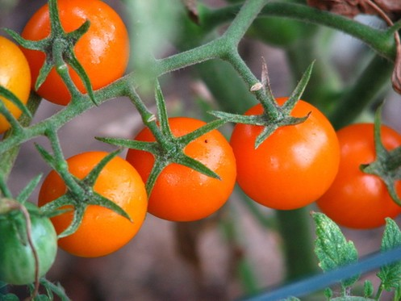
SUNSUGAR TMV
62 days. Each plant will produce many clusters of 1/2 inch or smaller, sweet golden cherry-sized, gorgeous fruit. A blue ribbon winner at one Fair declared it one of the sweetest and best flavored cherry varieties. Disease resistant. Indeterminate stake habit.

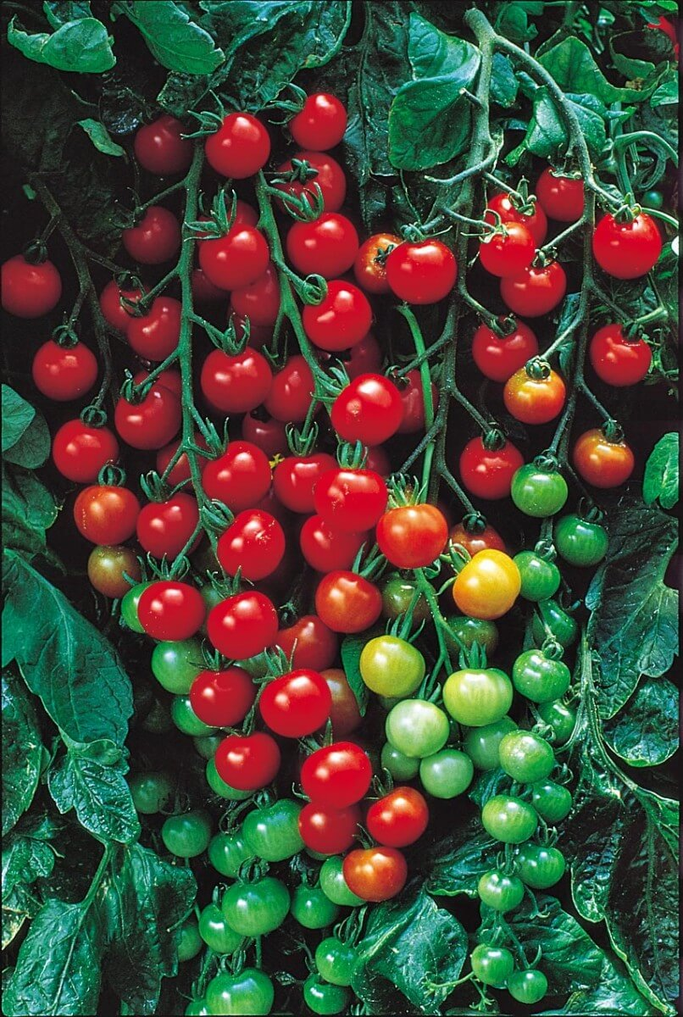
SUPER SWEET 100
- (F-1 Hybrid). 65-78 days. Long, branched clusters of deliciously sweet fruits high in sugar and vitamin C. More disease resistant than its cousin Sweet 100, giving plants a better chance where certain problems may be soilborne. You will be eating them right off the vine before they ever make it to the salad bowl. Perfect for snacking, salads and even juice. Indeterminate stake habit.

