Seasonal Plants and Live Goods
September, 2019
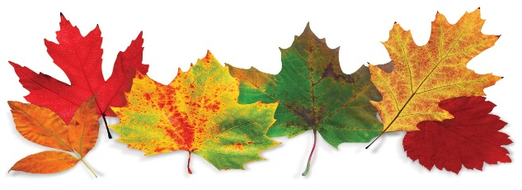
This Photo by Unknown Author is licensed under CC BY-NC-ND
6” Mums
6” Asters
6” Ornamental Kale
6” Fall Plants: $7 each or 3 for $20

6” Ornamental Peppers, $10
Celosia, $20

