Cool Weather Vegetables
September 2-7, 2019
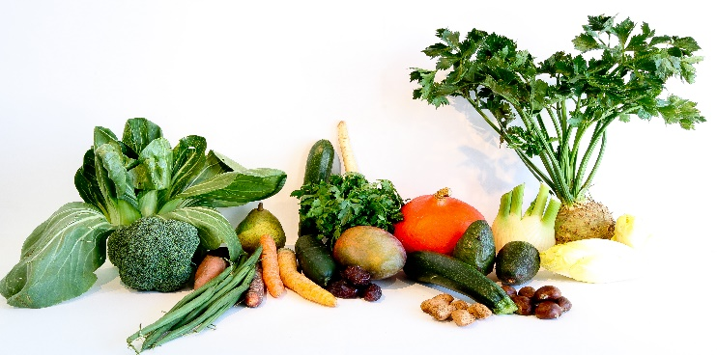
This Photo by Unknown Author is licensed under CC BY
All vegetables are in market packs.

Broccoli
Cauliflower
Brussel sprouts
Cabbage
Iceberg Lettuce
Romaine Lettuce
Pak Choi

