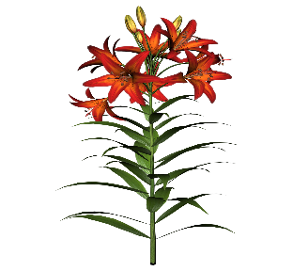
Bulb Inventory
This Photo by Unknown Author is licensed under CC BY-NC-ND
Fall 2019

Fall Flowering Crocus, Saffron | $8.00
Allium, California Baja Jumbo White | $10.00
Allium, Gladiator | $8.00
Allium, Graceful | $8.00
Crocus, Large Flowering Mixture | $8.00
Hyacinth, Easter Joy Mixture | $8.00
Narcissus, Dutch Master | $8.00
Narcissus, Mount Hood | $8.00
Narcissus, Tete A Tete | $8.00
Narcissus, Gold and Silver Medalist | $8.00
Tulip, Lilac Wonder | $8.00
Tulip, Wildflower Mixture | $8.00
Tulip, Mascotte | $8.00
Tulip, Hakuun | $8.00
Tulip, Parade | $8.00
Tulip, Pink Impression | $8.00
Tulip, Banja Luka | $8.00
Tulip, Kansas Proud | $8.00
Tulip, Purple Passion Mixture | $8.00
Tulip, Single Late Mixture | $8.00
Tulip, Flaming Parrot | $8.00
Tulip, Red Madonna | $8.00
Freesia, Double Mixture | $8.00

